# A Minor Project Final Report on

**New Age Shopping**

Submitted in Partial Fulfillment of the Requirements for

the Degree of **Bachelor of Engineering in Software Engineering**

Under Pokhara University

Submitted by:

**Aayush Basnet 171601**

**Jiwan Gharti 171719  
Jayas Sapkota 171718**

**Shibu Chapagain 171748**

Under the Supervision of:

**Mr. Prakash Paudal**

Date: **10 - 02 - 2021**

 **Department of Science and Technology**

**NEPAL COLLEGE OF**

**INFORMATION TECHNOLOGY**

Balkumari, Lalitpur, Nepal

# ACKNOWLEDGMENT

We would like to extend our sincere gratitude towards Department of Software Engineering, Nepal College of Information technology for providing us an opportunity to undertake an exclusive minor project and a chance to explore our capability.

Training is the first step in the practical field from where one learns how to apply theory principles for this the practical purposes. To develop a successful ecommerce website, one needs understanding and co-ordination from all those who are directly and indirectly involved in this.

We would like to thank all our teachers for providing us with help and support during different stages of the development of the project. We would like to express our gratitude to our guide and supervisor, Mr. Prakash Paudal for providing so much help, support and encouragement.

Thank You.

# ABSTRACT

*‘New age shopping’ is a web-based application. It’s an e-commerce platform for a retail store. Store owner can sell their product online. It enables customers to select goods and make order. The method of payment that we are going to implement in this webapp is Online payment.*

*This webapp will be designed using HTML, CSS, JavaScript and Python. Bootstrap and Django as a framework of CSS and Python respectively will be used along with its dependencies. It will have PostgreSQL as database.*

**Keywords**: *e-commerce, webapp, goods, order*

TABLE OF CONTENTS

ACKNOWLEDGMENT I

ABSTRACT II

LIST OF FIGURES IV

LIST OF TABLES V

1. INTRODUCTION 1

1.1. PROBLEM STATEMENT 1

1.2. OBJECTIVES 2

1.3. SIGNIFICANCE OF THE STUDY 3

2. LITERATURE STUDY / REVIEW 4

3. METHODOLOGY 5

3.1. ARCHITECTURE 5

3.1.1. USE CASE DIAGRAM 5

3.1.2. ER DIAGRAM (ERD) 6

3.1.3. SEQUENCE DIAGRAM 7

3.2. MODEL 8

3.3. WORK DETAILS 9

3.3.1. TASK DISTRIBUTION 9

3.3.2. TIME SCHEDULED 9

3.3.3. LIMITATIONS OF OUR PROJECT 10

4. CONCLUSION 11

5. FURTHER WORKS / RECOMMENDATION 12

6. BIBLIOGRAPHY / REFERENCES 13

7. APPENDIX 14

# LIST OF FIGURES

Figure 1: Use case diagram 5

Figure 2: ER Diagram (ERD) 6

Figure 3: Sequence diragram for customer side 7

Figure 4: Sequence diagram for merchant side 7

Figure 5: Iterative and Incremental Model 8

Figure 6: Homepage 14

Figure 7: Home page products 14

Figure 8: Single Product details with average ratings 15

Figure 9: Details and Review section in single product details 15

Figure 10: Add to cart with delete messages 16

Figure 11: Checkout form 16

Figure 12: Payment with total orders and price 17

Figure 13: Online payment through Paypal (Client side) 17

# LIST OF TABLES

Table 1: Task Distribution 8

Table 2: Time Scheduled 8

# INTRODUCTION

Online Shopping or e-shopping is a form of electronic commerce which allows customers to directly buy goods or services from seller over the internet using a web browser. An online shopping system permits a customer to submit online orders for items or services.

E-Shopping is a boon as it saves lot of time. Online shopping is a process whereby consumers directly buy goods, services etc. from a seller without an intermediary service over the Internet. Shoppers can visit web stores from the comfort of their house and shop as by sitting in front of the computer. Online stores are usually available 24 hours a day and many consumers have internet access both at work and at home. So, it is very convenient for them to shop Online. One of the most enticing factors about online shopping, particularly during holiday season is, it alleviates the need to wait in long lines or search from a store for a particular item.

## PROBLEM STATEMENT

In this busy world, people have time limits. Going to shopping and spending hours and hours doesn’t make us productive. And selling offline through the shop limits the income of the seller. Seller cannot reach a greater number of customers to make huge number of transactions. Here, the challenge is to guide the both the seller and customer having lack of time to sell and buy goods by saving their time and to provide services 24/7 hours.

After the implementation of our webapp vendors can sell and customer can shop the item through their home or their office which ultimately saves the time. Customers can utilize the shopping time in other productive works. Not only that they can also search for their desirable item in just a matter of time. Customers will be able to shop the item in the reasonable price. This will ultimately change the way of shopping and help to live life in modern way. On the other hand, the seller can get chance to reach more customers and increase their profit.

## OBJECTIVES

We have developed this project to deliver the shopping into web platform. The main objectives of the project are as follows:

* To reach out to a larger Audience.
* Selling a service or product.
* Providing vendor support or customer service.
* To provide user interface where customers can do online shopping in easy way.
* To understand the present status and trends of E-Commerce.
* To make accurate, efficient, and time saving e-commerce platform.
* To modernize the primitive way of shopping.

## SIGNIFICANCE OF THE STUDY

Electronic commerce, or e-commerce, is the way of shopping for and commercializing product and services on the web. Aside from buying and selling, many people use the Internet as a source of information to compare prices and see what's new before making a purchase online or in a physical store.

With the increasing Internet, the global business community is rapidly moving towards Business-to Business (B2B) e-Commerce. The buyers gain a clear advantage when the Internet gives them access to the global market, by which they can compare prices across regions, find out whether prices vary by order fragmentation and get awareness about substitute products. Due to transparency of the market, customer can compare the services of various e-commerce sites easily. For instant, in case of e-commerce the competitors are one click away from customer. If clients are not happy with the products, prices or services offered by a particular ecommerce site, they are able to change much more easily than in the physical. From the Sellers’ point of view, they don’t need to have physical existence of shop.

In this project, we provide the buyers wide variety of products, lower cost of product than traditional shopping, exciting offers and shopping deals notifications and many more. And for vendor we provide the opportunity to sell their products online.

# LITERATURE STUDY / REVIEW

E-Shopping is the latest development of human history. Commerce has evolved over the centuries. Prior to the evolution of money, it was the simple-barter process where things could be exchanged, say milk for grains. It opens new doors for the problems of real-world shopping phenomenon. The idea of integrated market and services solved many problems and today it is not a barrier to shop at a specific location, but we can shop wherever we want. E-Shopping provides multiple opportunities involving many challenges as well.

In the context of Nepal, different people have developed different methods, techniques and tried working in this field. Different key words had been put to search such websites and we found some of them:

1. Daraz Nepal
2. Sasto Deal

# METHODOLOGY

## ARCHITECTURE

### USE CASE DIAGRAM

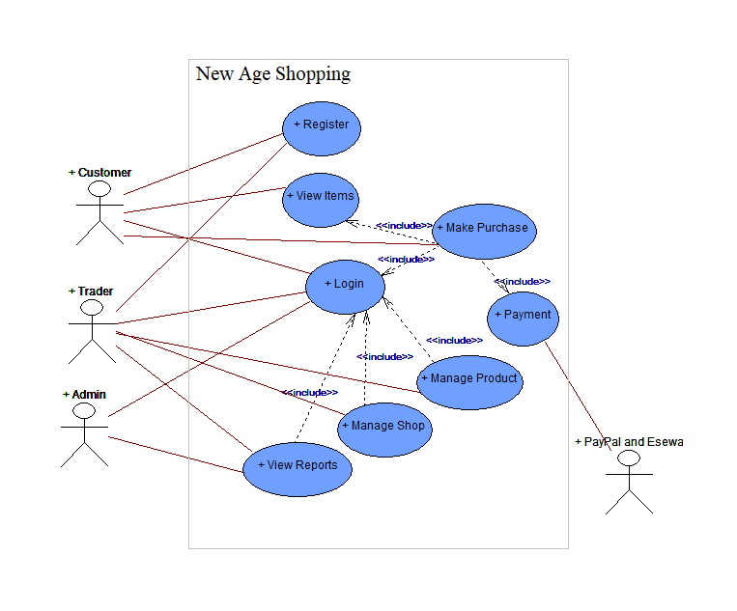

Figure 1: Use case diagram

### ER DIAGRAM (ERD)

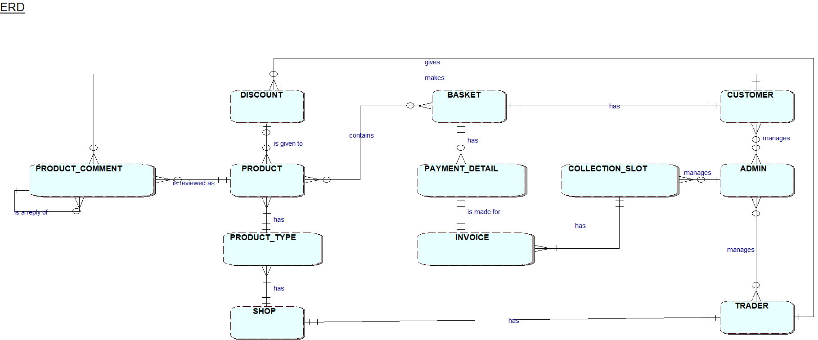

Figure 2: ER Diagram (ERD)

### SEQUENCE DIAGRAM

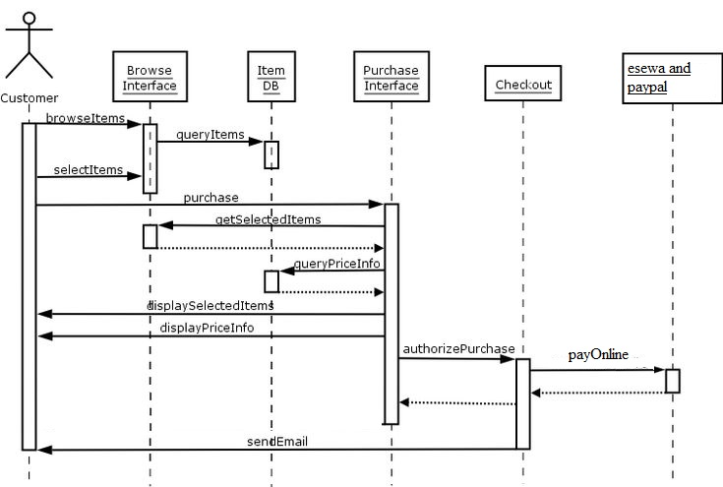

Figure 3: Sequence diragram for customer side

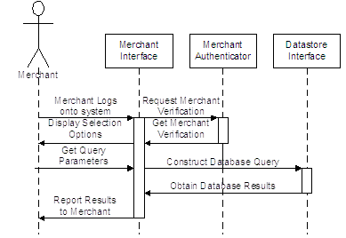

Figure 4: Sequence diagram for merchant side

## MODEL

We have used the Iterative and Incremental Model of Software Process Model. This Evolutionary S/W process model combines the interactive nature Prototyping Model plus the control and systematic aspect of linear sequential model. It has potential for rapid development of incremental versions of the software. Software is developed in a series of incremental releases.

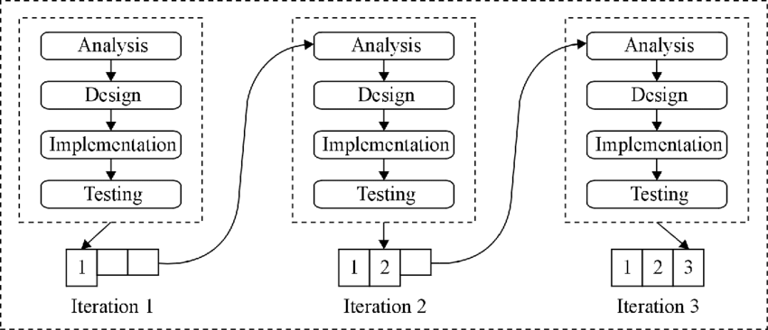

Figure 5: Iterative and Incremental Model

## WORK DETAILS

The project schedule has been designed and done as per requirements and constraints involved. This project was scheduled to be completed in about 20 days. Requirement analysis have been given more emphasis. Research and database management was done first and well documented. Debugging and Testing was to be done after the completion of the project.

### 3.3.1. TASK DISTRIBUTION

Table 1: Task Distribution

|  |  |  |
| --- | --- | --- |
| SN | Project task | Person |
| 1 | Project analysis/requirement analysis | Jiwan, Aayush, Shibu, Jayas |
| 2 | System design | Jiwan, Aayush, Shibu, Jayas |
| 3 | Coding | Jiwan, Aayush |
| 4 | Model design | Jiwan, Aayush |
| 5 | Database design | Jiwan, Aayush |
| 6 | Testing and debugging | Jayas, Shibu |
| 7 | Documentation | Jayas, Shibu |

### 3.3.2. TIME SCHEDULED

Table 2: Time Scheduled

|  |  |  |  |  |  |  |  |  |  |
| --- | --- | --- | --- | --- | --- | --- | --- | --- | --- |
| Project Proposal |  |  |  |  |  |  |  |  |  |
| Specification |  |  |  |  |  |  |  |  |  |
| Project Management Plan |  |  |  |  |  |  |  |  |  |
| Project Requirements Specifications |  |  |  |  |  |  |  |  |  |
| Project Design Description |  |  |  |  |  |  |  |  |  |
| Coding and Implementation |  |  |  |  |  |  |  |  |  |
| Documentation |  |  |  |  |  |  |  |  |  |
|  | 09/09/2021 | 11/09/2021 | 13/09/2021 | 16/09/2021 | 29/09/2021 | 30/09/2021 | 01/10/2021 | 02/10/2021 | 02/10/2021 |

### 3.3.3. LIMITATIONS OF OUR PROJECT

We have following limitations:

* Inventory Management:

Merchant product count can only be decreased by admin after purchase.

* No real time synchronization.

# CONCLUSION

In general, today’s businesses must always strive to create the next best thing that consumers will want because consumers continue to desire their products, services etc. to continuously be better, faster, and cheaper.  In this world of new technology, businesses need to accommodate to the new types of consumer needs and trends because it will prove to be vital to their business’ success and survival.  E-commerce is continuously progressing and is becoming more and more important to businesses as technology continues to advance and is something that should be taken advantage of and implemented.

From the inception of the Internet and e-commerce, the possibilities have become endless for both businesses and consumers.  Creating more opportunities for profit and advancements for businesses, while creating more options for consumers.  However, just like anything else, e-commerce has its disadvantages including consumer uncertainties, but nothing that cannot be resolved or avoided by good decision-making and business practices.

There are several factors and variables that need to be considered and decided upon when starting an e-commerce business.  Some of these include: types of e-commerce, marketing strategies, and countless more.  If the correct methods and practices are followed, a business will prosper in an e-commerce setting with much success and profitability.

# FURTHER WORKS / RECOMMENDATION

Following are the features and tools that can be introduced and managed to build a secure, safe and advanced website:

* Search engine optimization
* Product recommendations
* Login through social accounts, phone number or email
* Payment with Card /e-Sewa
* Mail to customer after making purchase
* Making website fully responsive

# BIBLIOGRAPHY / REFERENCES

[1]Title:“Django”,[online].Available,URL:”https://en.wikipedia.org/wiki/Django_(web_framework) [Accessed: 24-March-2021 at 05:12 pm].

[2] Title:“HTML”,[online].Available,URL:“ https://en.wikipedia.org/wiki/HTML.” [Accessed: 23-March-2021 at 05:15 am].

[3] Title:“JavaScript”,[online].Available,URL:“ https://en.wikipedia.org/wiki/JavaScript” [Accessed: 24-March-2021 at 05:12 pm].

[4] Title:“CSS”,[online].Available,URL:“ https://en.wikipedia.org/wiki/CSS” [Accessed: 23-March-2021 at 05:12 am].

[5] Title:“Bootstrap”,[online].Available,URL:“https://en.wikipedia.org/wiki/Bootstrap_(front-end_framework)” [Accessed: 23-March-2021 at 05:12 am].

[6] Title: “E-Commerce – A Study of Benefits and Challenges”, [online]. Available, URL: “http://ignited.in/I/a/78872” [Accessed: 25-March-2021 at 03:12 pm].

# APPENDIX

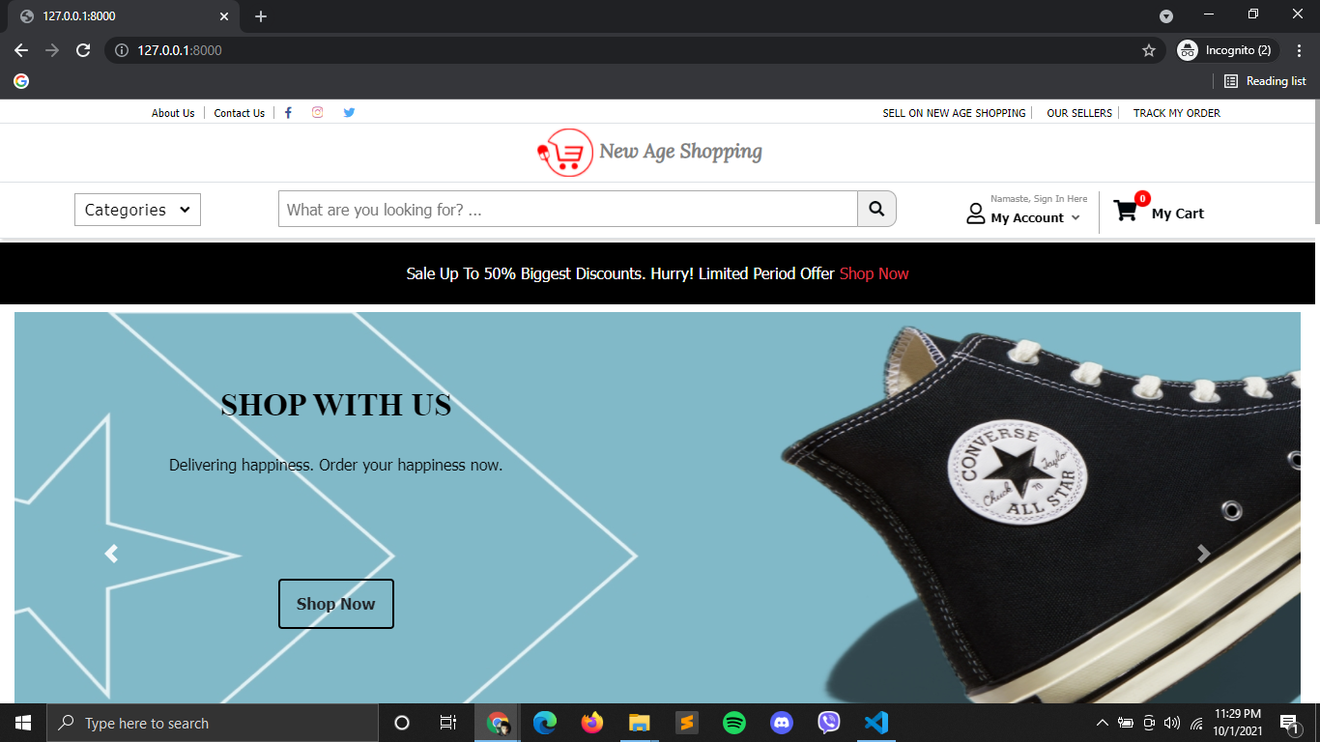

Figure 6: Homepage

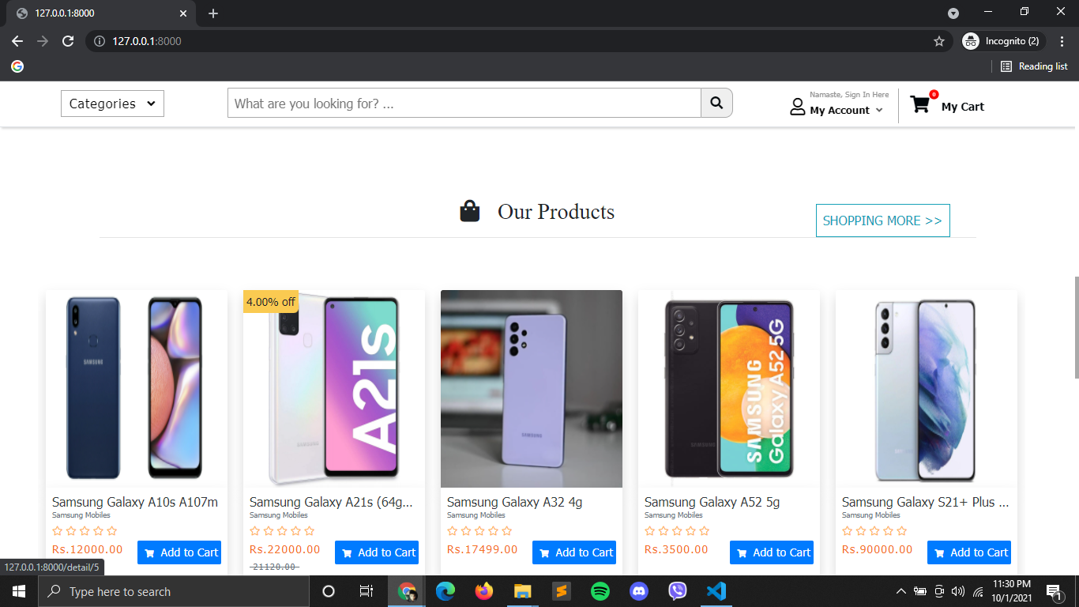

Figure 7: Home page products

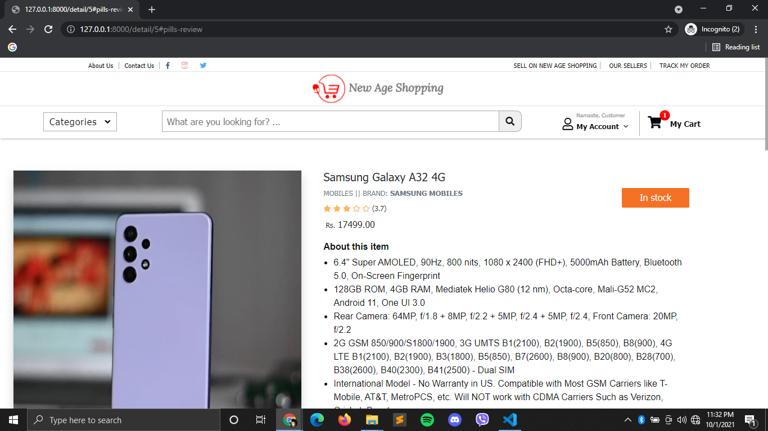

Figure 8: Single Product details with average ratings

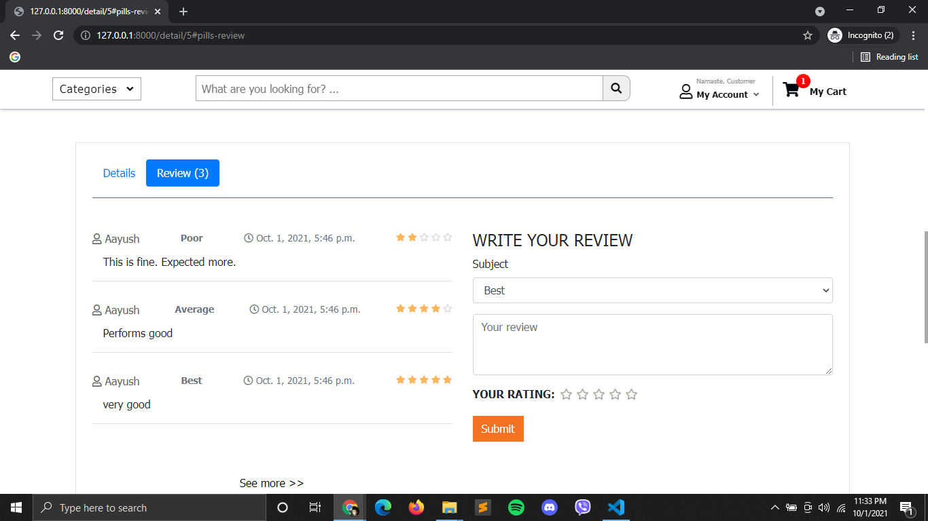

Figure 9: Details and Review section in single product details

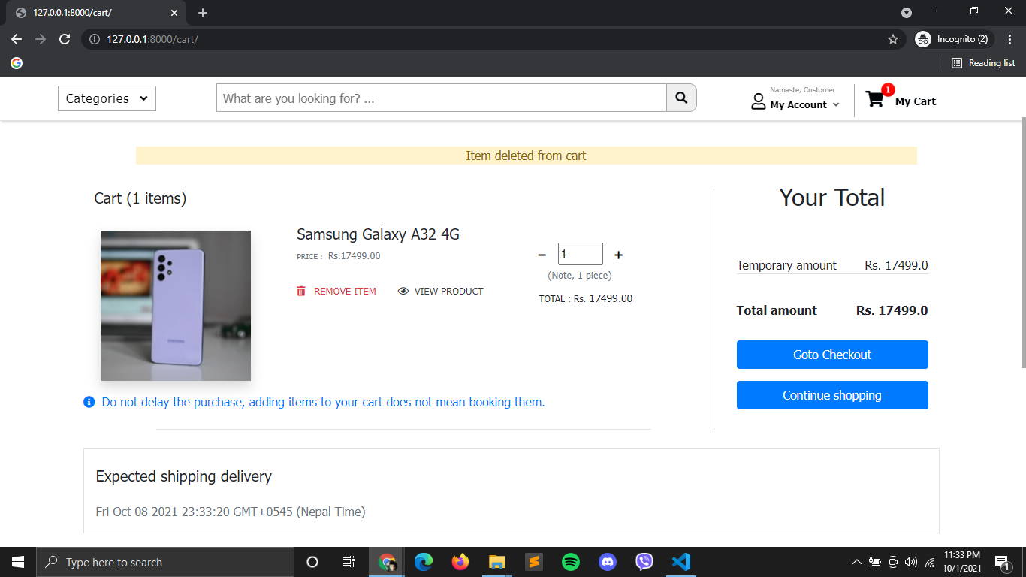

Figure 10: Add to cart with delete messages

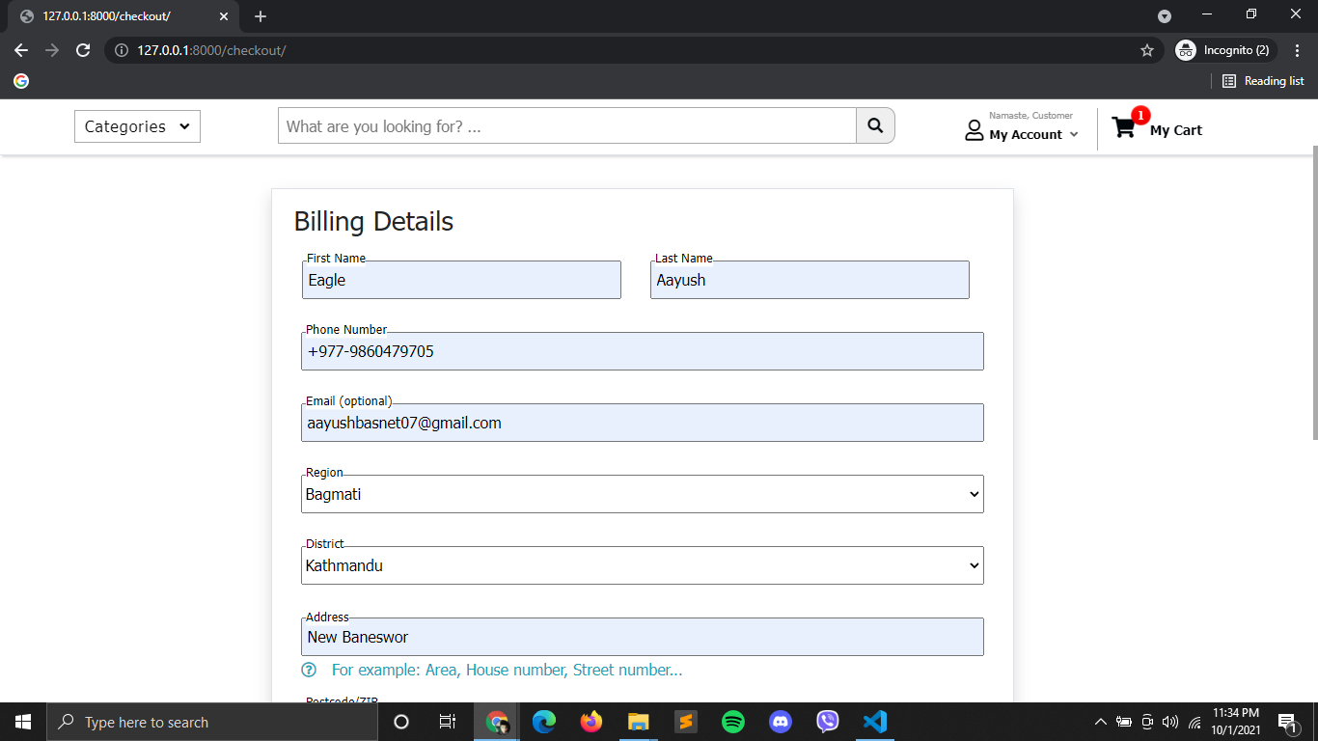

Figure 11: Checkout form

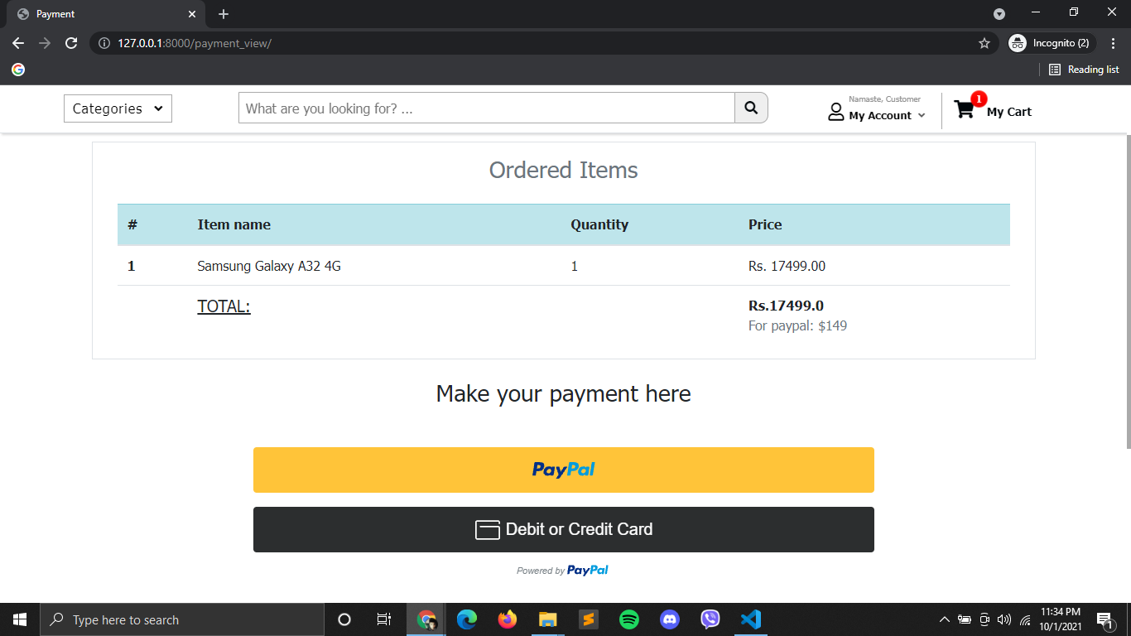

Figure 12: Payment with total orders and price

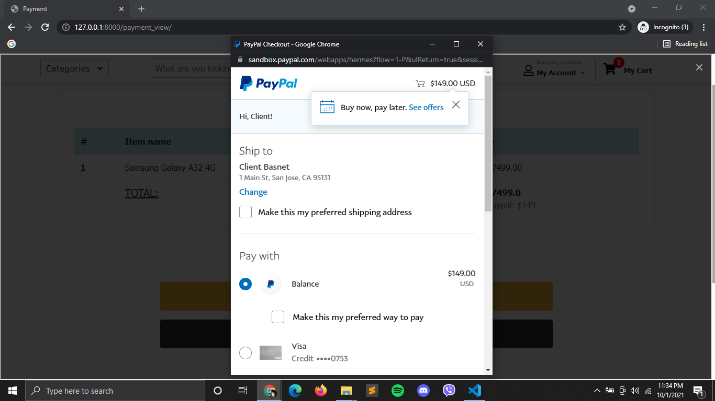

Figure 13: Online payment through Paypal (Client side)